IFSM 370 Project 3: Case Study
Name:
Tutor:
Institution:

Requirements analysis
Convergence is the unification of networks into one network for local area networks (LANs) and storage area networks (SANs). Five specific business requirements that relate to the design and implementation of the network include;
i) Simple and reliable
Traditionally, businesses used to have huge data centers equipment. These consumed a lot of power and required massive cooling. Today, it's shrinking to a lot of smaller spaces and virtual infrastructure adopted. Convergence aids in the reduction of the storage and network infrastructure leading to doing more with less. Fiber Channel over Ethernet (FCoE) and iSCSI are the main storage and network convergence enablers. Businesses can use both the traditional fiber channel for storage while at the consequentially adapting server virtualization using higher Ethernet output demands.
ii) Both storage and network infrastructure network have high speeds
Fiber channel (FC) speeds are exceeded by Ethernet. Some years back speeds of 100Mbps were considered fast but now speeds of 10Gbps Ethernet are available now. The transmission speeds will continue to increase as vendors are working on higher speeds.
iii) Server resources and management be better utilized
The use of a united infrastructure for the different network traffic, costs for procurement, installation, management and operation of infrastructure are lowered. Where a number of cables, adapters, and switches were needed for every network, a single infrastructure replaces all, resulting in a reduction of equipment, cabling, and power required.
iv) Storage and networking convergence
As with fiber channel, storage area networks, which perform highly in storage networking, the Ethernet improves both speed and storage without losses occurring. Storage is done with FC port connected to FC switches. Servers re-equipped with adapters which connect to FC switches. The set of switches form a network for traffic storage.
v) Be easy for workloads to move in the virtual world
Fibre channel standards were set in the early 1990s with businesses adopting it as preferred storage networks. It stood out from alternatives, offering high speeds and low losses as it doesn’t drop packets when there is congestion of the network. Fiber channels are more advanced for storage network, but some of the things to consider include: Firstly, it’s a separate network from the Ethernet network; additional cost from infrastructure is required. Secondly, it’s a different technology which needs a different skill set adding to the cost of personnel.
LAN Technology solution
A local area network is set computers network in a small geographical area such ad an office building, computer laboratory, school, home or a group of building. It is composed of connected work stations which are set in such a way each of them can access and share devices such as storage devices, scanners or printers. In this case study, structured cabling is essential for the three work stations. The wiring will require a pair of twisted copper cables to ensure secured data transmission. All the cables are stars from the distribution rack (router) to the three stations (laptop computer, work station and desktop PC).
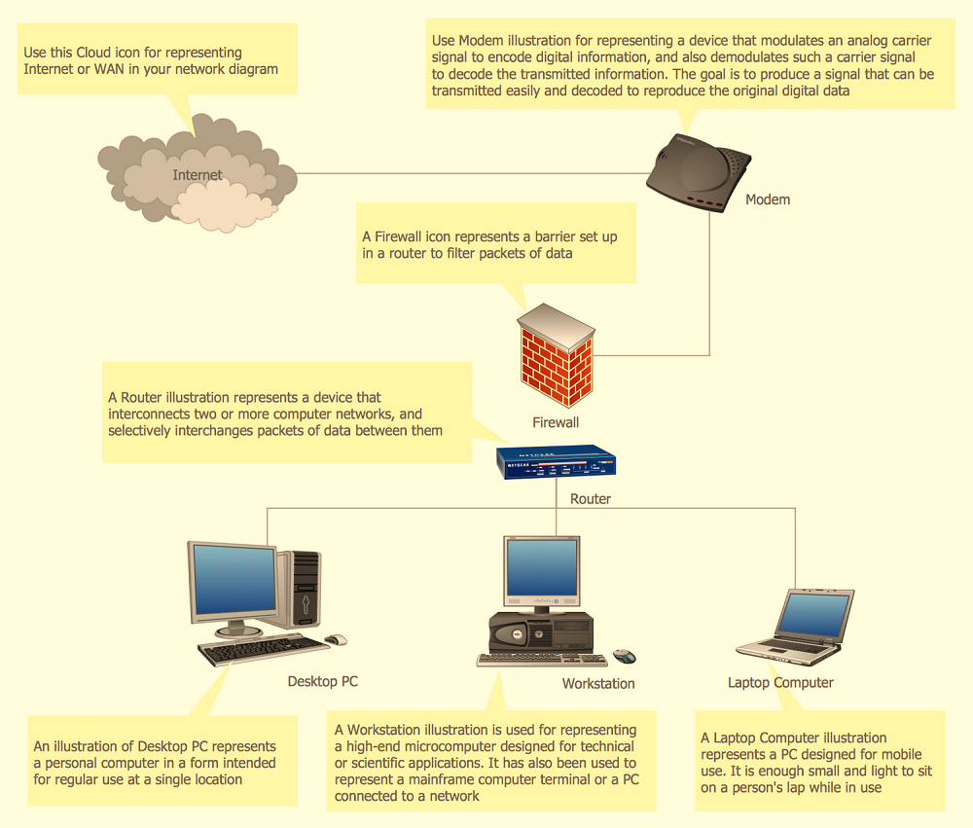
WAN Technology solution
A wide area network is a communication network for data which operates within a specified geographical scope that is beyond LAN. Various types of serial connections is used in a wide area network connection.
They also use the service of carriers such as cell phone companies or cable companies, satellite systems, and network providers. Typically, the customer equipment will use various types of serial connections to connect to the wide area network.
The T-1 line is used for processing the transmissions on WAN.
DS-3 is a telecommunication circuit which is used in receiving and transmitting speed.
A remote VPN is used to establish a safe connection for internet in order to access resources that could be restricted from the head office.
ADSL is a broadband communication technology to allow data and communication connection. It is designed to allow all of their staff to communicate and collaborate quickly, efficiently, without a lot of network delay.

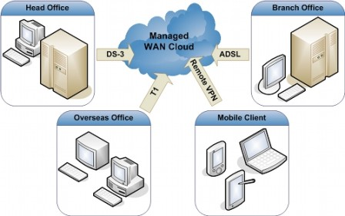

VPN Technology
A virtual private network is a network method where two ending points makes up a single private connection. All that is required in a mobile device for a VPN to run is only a SIM card with no need for any software installation.
The VPN server from the head office is connected to the end points of the remote VPN clients and configuration is done on the remote systems i.e. roaming users and the two regional offices. The VPN server acts as a router at the end-point of each local network to be connected. The tunneling protocol is used to wrap each of the packets transmitted for it to be read in any public network through the process of encapsulation.
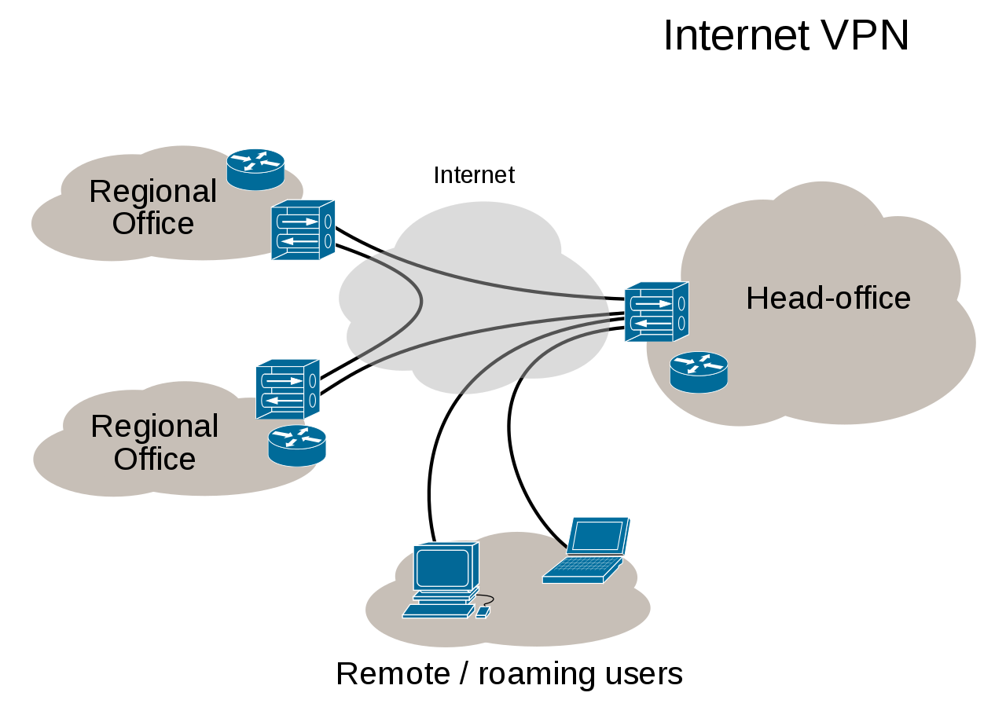
Conclusion
From the three technology solution, a VPN technology solution is the best for their business. It is clear that they will all work from different work stations in different locations. LAN network may be cheap to install but limited in proximity. WAN could be convenient since it is more developed and offers more connection that on a LAN network but it operates with the same proximity as LAN. VPN technology may be costly compares to the other three technologies, but it does suite them in terms of proximity and sharing of data and communication network. Therefore, VPN network offers more benefits that cost.

References
Cavalieri, S., & Panno, D. (1998). A novel solution to interconnect FieldBus systems using IEEE wireless LAN technology. Computer Standards & Interfaces, 20(1), 9-23.
Crow, B. P., Widjaja, I., Kim, J. G., & Sakai, P. T. (1997). IEEE 802.11 wireless local area networks. IEEE Communications magazine, 35(9), 116-126.
Xiang, Z., Song, S., Chen, J., Wang, H., Huang, J., & Gao, X. (2004). A wireless LAN-based indoor positioning technology. IBM Journal of research and development, 48(5.6), 617-626.

